Task-1: Lab Setup & Environment Configuration Report
Internship: Cybersecurity & Ethical Hacking
Organization: ApexPlanet Software Pvt. Ltd.
Name: Sanjay Reddy
Task: Foundations & Environment Setup
Duration: Days 1–12

Objective
To build a secure virtual lab environment for cybersecurity practice by configuring:
- Kali Linux (Attacker Machine)
- Metasploitable 2 (Target Machine)
- Host-Only Network Isolation
- Basic Tool Familiarization (Nmap, Wireshark)

Tools & Technologies Used
Tool | Purpose
VirtualBox | Virtualization platform
Kali Linux | Attacker system
Metasploitable 2 | Vulnerable target system
Nmap | Network scanning
Wireshark | Packet capture & analysis

Kali Linux Setup
- Imported Kali VirtualBox image
- Allocated 4GB RAM
- Assigned 2 CPU cores
- Configured Host-Only network
Verification:
ifconfig
whoami
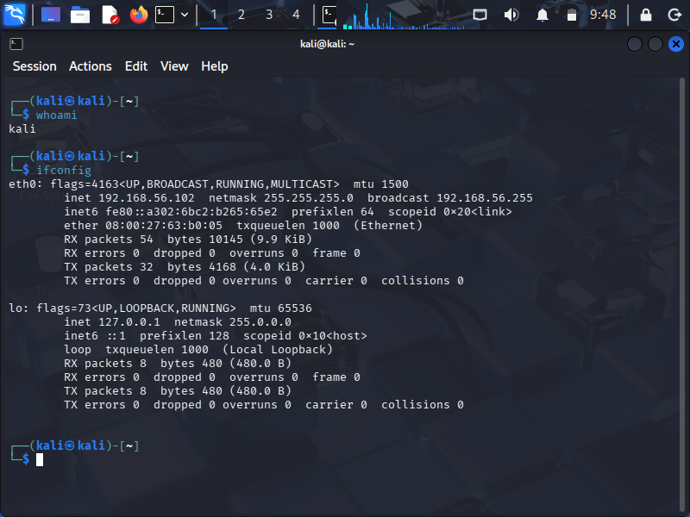

Metasploitable Setup
- Added VM in VirtualBox
- Configured Host-Only Adapter
- Booted successfully
Verification:
Ifconfig
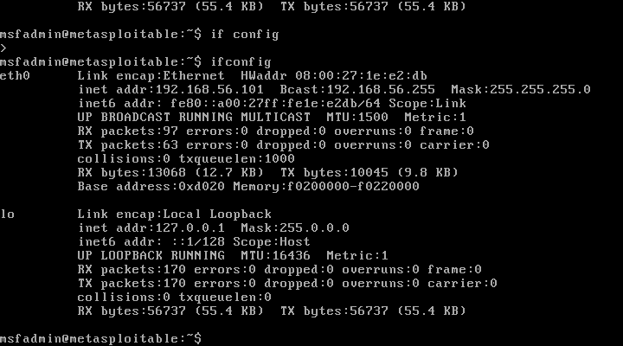

Network Verification
From Kali:
ping <metasploitable-ip>
Result:
- Successful ICMP reply
- Network connectivity confirmed
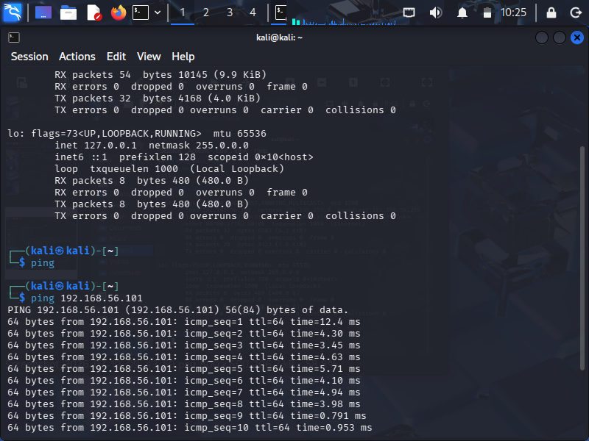
7️⃣

Nmap Scan Verification
Command used:
nmap <target-ip>
Observations:
- Multiple open ports detected
- Services identified (FTP, SSH, HTTP etc.)
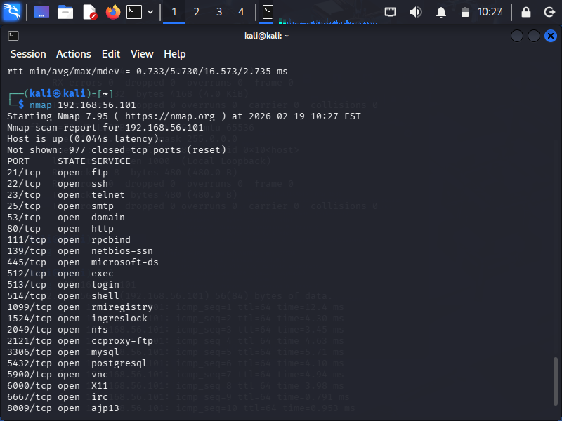
Wireshark Packet Capture
- Started capture on Host-Only interface
- Generated ICMP traffic using ping
- Verified packet capture
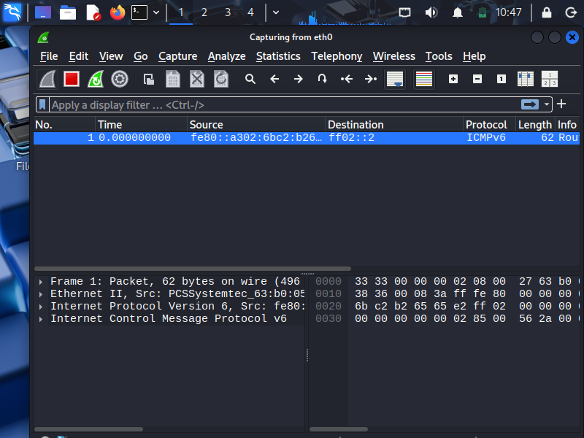
Key Learnings
- Understood attacker ↔ victim lab setup
- Configured isolated private network
- Performed basic reconnaissance and scanning
- Observed live network packets
- Gained hands-on exposure to cybersecurity tools

Conclusion
The virtual cybersecurity lab was successfully configured and validated.
All required tools were tested and network communication between attacker and target systems was confirmed.
This environment will be used for further security testing tasks in upcoming internship modules.

